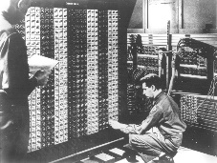
Advanced Placement Computer Science
Shenendehowa HS mr Hanley
Unit 3: Primitives, References & Objects
Lesson: Parameter Passing
Last Updated: 10/17/2017

Lesson: Parameter Passing Mechanisms
Last Updated: 100/11001/1100

Parameter Passing :

Primitives and References are passed by ________________
This means that the

Example 1: passing a primitive:
public class Example1 {
public static double findAvg(double a, double b, double c) {
double avg = (a + b + c) /3;
a = a + 1; //attempt at a side effect
return avg;
}
public static void main(String[] args) {
double n1 = 10, n2 = 20, n3 = 32;
double result = findAvg(n1, n2, n3);
System.out.println(“For the #’s” + n1 + “\t” + n2 + “\t” + n3 + “\t” + “Avg = “ + result);
}
}
Example 2: passing a reference:
public class Student { //constructor not shown
public String name;
public double test1, test2, test3;
}
public class Example2 {
public static double findStuAvg(Student s) {
double avg = //you finish
s.test1 -= 10; //attempt at a side effect
return avg;
}
public static void main(String[] args) {
Student s1 = new Student (“Johnny Rocket” , 100, 87, 91);
double result = findStuAvg(s1);
System.out.println(“S1”+s1.test1+“\t”+s1.test2+“\t”+s1.test3+“\t”+“Avg = “ + result);
}}

